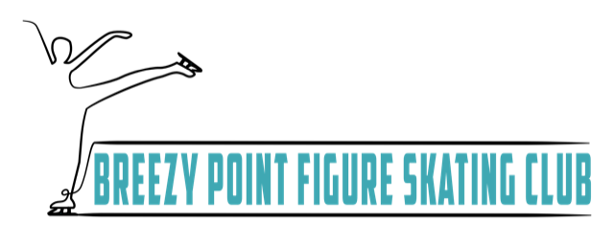
BPFSC Grievance Policy
All Breezy Point Figure Skating Club Policy and Procedures will follow local laws, National Governing Body: US Figure Skating, US Safe Skate, US Center for Safe Sport and BPFSC Bylaws and Handbook.
Procedure:
If a Grievance is of “sexual” or ”criminal” nature it will immediately be reported to the appropriate governing body.
- Submit the BPFSC Grievance Form to the BPFSC President or Safe Skate Chair
  - The Safe Skate Chair will acknowledge to the Grievant that their complaint was received within 24 hours and take any immediate steps to protect the skater involved.
- The Safe Skate Chair will appoint a Review Panel to handle the complaint. The Review Panel will consist of at least three members. No Member including the (Safe Skate Chair or BPFSC Board Members) with a Conflict of Interest will be allowed to serve on the Review Panel or vote on the Grievance.
  - The Review Panel will meet with both sides of the Grievance within 15 days of receiving the Grievance
  - The Review Panel will discuss and report a summary back to the Board of Directors for Recommendation of Resolution.
  - Board of Directors will vote on Resolution
  - Once the Board of Directors has voted on Resolution both parties will be informed of the decision and action plan, if needed, will be implemented.
The club president or club officer who received the complaint will appoint a review panel of three unbiased people from within the club board or club membership not related or involved with the alleged incident/infraction. The president or officer will name one of the members of the review panel as chair of the review panel. The review panel will evaluate the complaint and determine what, if any, further action is necessary.
If accepted, a copy of the complaint will be sent to the person against whom the complaint has been filed. The parties to the matter will be notified in writing of the names of the members of the review panel. In the event any party believes that a member of the review panel has a conflict of interest, an objection can be submitted in writing to the club president or officer within three days of the notification in writing. The objection will indicate with specificity the basis of the conflict of interest. The club president or officer shall determine if the review panel member will be replaced. The decision of the club president or officer is final. The respondent will have 10 days to respond to the complaint in writing. The review panel will send a copy of the response to the person filing the complaint. Unless the chair of the review panel determines otherwise, the chair of the review panel will then schedule a meeting with all parties involved within seven days for a full investigation in the matter and come to a decision to resolve the complaint.
The review panel will report the findings and recommendations to the club board within seven days of the last meeting scheduled in the matter. The decision will be presented to the board who may adopt the recommendation, modify the recommendation or return the matter to the review panel with directions for further investigation and or for further recommendations by the review panel. Once the decision is adopted or modified by the board, the outcome is considered final and will be communicated in writing to both parties within seven days of the action by the board.

Disciplinary Action:
All disciplinary action shall be documented and stored in the BPFSC Club Records. The goal of the BPFSC Grievance Policy is to create a Safe Environment for our Skaters and to correct behavior before termination of Club Membership is required. The Board of Directors has the option of using the following Progressive Discipline Process:
- Written Warning of Undesirable Behavior
- Probationary Period of Club Member or Parent/Guardian of Skater defined at the time of the disciplinary action with specific start and end dates, date for review
- Two Week Club Member and/or Parent/Guardian Suspension from the use of Home Club Ice, Amenities or Activities
- Removal of the Club Member and Parent/Guardian for the Remainder of the Season with potential termination of Club Membership
BPFSC considers both parties of the Grievance with equal rights to be heard. Additionally any perceived Retaliation from either side of the Grievance should be reported to the BPFSC Safe Skate Chair. (See US Figure Skating WhistleBlower Protection Policy).
BPFSC reserves the right to reference US Figure Skating Club Resources Sample Process of Conflict Resolution for Clubs.

