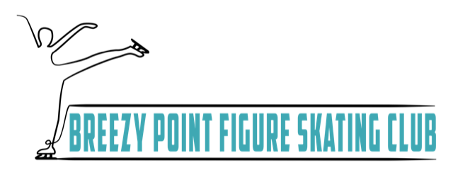
Grievance Report
To report sexual misconduct or child abuse, report immediately to appropriate law enforcement agency and to the U.S. Center for Safe Sport
If you would like to report a misconduct complaint or code of ethical conduct complaint, please fill out the following form.
While all reporting is kept confidential you may report an anonymous complaint. Please keep in mind that an anonymous complaint may make it more challenging for BPFSC to investigate and resolve.
Name:______________________________________________________________
Phone Number:________________________ Email: _______________________
Did this occur over multiple days:
- Yes Time Frame:_____________________________________________
- No _______________________________________________________
Incident Details:______________________________________________________
___________________________________________________________________
___________________________________________________________________
___________________________________________________________________
___________________________________________________________________
___________________________________________________________________
___________________________________________________________________
___________________________________________________________________
___________________________________________________________________
___________________________________________________________________
___________________________________________________________________
___________________________________________________________________
___________________________________________________________________
___________________________________________________________________
___________________________________________________________________
___________________________________________________________________
Parties Involved: _____________________________________________________
Resolution Seeked: ___________________________________________________
___________________________________________________________________
___________________________________________________________________
___________________________________________________________________
Violation Noted:
- Sexual Misconduct
- Physical Misconduct
- Emotional Misconduct
- Bullying, Threats and Harassment
- Hazing
- Willful Toleration
- Bylaw or Handbook Violation

